Chapter 14
Communication Channel Technology

14.4 (BL2+)The wide bandwidth of the fiber optic cable is necessary to meet the bandwidth needs of modern communication, particularly for wideband Internet connectivity and high definition digital television. The number of users demanding wideband Internet connectivity has increased tremendously in the last few years, as has the number of television stations broadcasting in high definition. Much of the modern use of the Internet incorporates streaming multimedia. The tremendous bandwidth required to meet the demand and competition from alternative technologies, such as satellite, cable companies, cellphone technology, and new wireless technologies, have compelled traditional phone companies to install fiber optic cable to meet the requirements of modern communication. Cellphone technology has increasingly replaced traditional landline telephone service, and has moved rapidly into Internet communication as well. The Internet and cable company competitors have moved into the area of telephone service. Phone companies have had to improve their technology to survive in an era of rapidly changing communication requirements.

14.13. (BL2-) The answer to this question depends on the location of the station, the self-identification of the station (XYZ-AM or XYZ-FM), and the particular radio frequency band where the station broadcasts from. (For example, in the United States, stations in the 550 KHz. to 1610 KHz. band all broadcast in AM, while those in the band 88-108 MHz. all broadcast in FM.) The broadcast bandwidth is determined by the minimum separation of stations mandated by the frequencies assigned in an area. For example, in the US, stations are separated by 200 KHz.

14.17. (BL2)

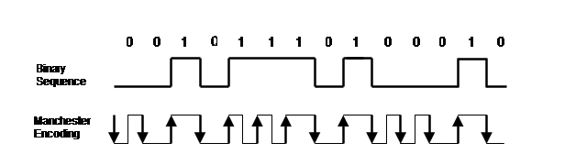

14.18 (BL2)

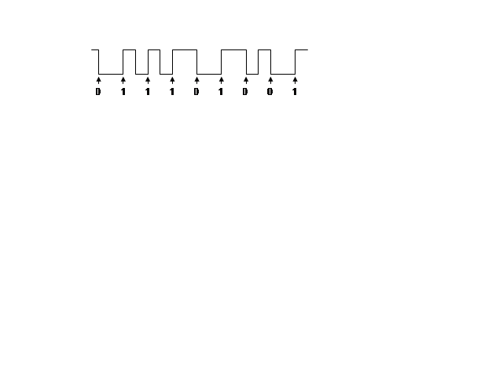
14.19 (BL2)
1101 0000 1100 1101
11011 11110 11010 11011
binary sequence

5B

14.20 (BL2) a.
5B

0000 0111 1100 0000
11110 01111 11011 11110
binary sequence

0011 0100 0011 0101
10101 01010 10101 01011
5B
b.
binary sequence

